Testing method dengan PHPUnit

Pengguna memasukan Flow dengan model BDD

Generate BDD menjadi UseCase

Generate UseCase menjadi GUI

Menentukan atribut dan method pada GUI

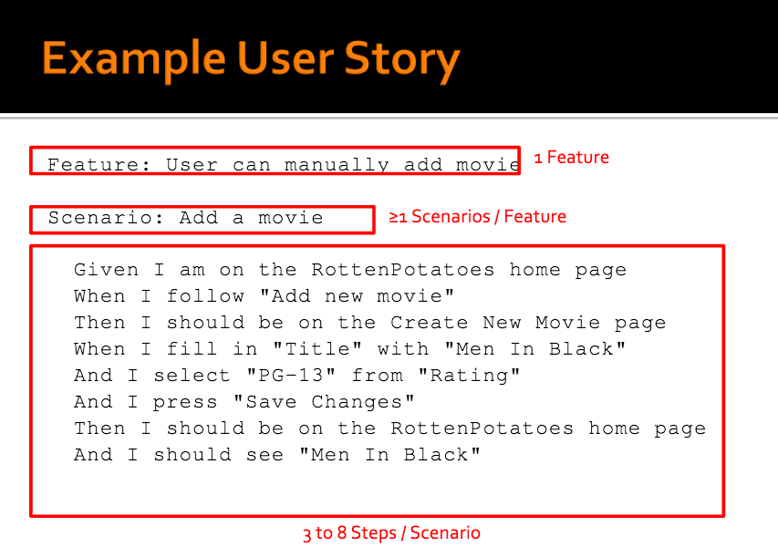

**UseCase**

Given I=Precondition

Scenario=Goal

When I || When I && AND I = Aktor

Then I || Then I && AND I = Sistem

|  |  |  |
| --- | --- | --- |
| GOAL ( SCENARIO) | Add a movie | |
| PRECONDITION  (GIVEN I AM) | On the Rotten Potatoes Home page | |
| AKTOR | | SISTEM |
| Follow “add new movie” | |  |
|  | | On the Create New Movie Page |
| Fill in”Title” with “Men In Black” | |  |
| Select “PG-13” from “Rating” | |  |
| Press “Save Changes” | |  |
|  | | On the RottenPotatoes home page |
|  | | See “Men In Black” |

**UI**

MEN IN BLACK

Save Changes

PG-13

Title

Rating

Textbox “String”

Dropdown String array”PG-13,PG-21”

Button

MEN IN BLACK

Save Changes

PG-13

Title

Rating

**GUI**

Atribut:

1. String Title
2. String array {PG-13,PG-21}

Method: Save_Changes(String Title, String array{PG-13,PG-21})